Warm-up 11
Sept. 2
We are going to draw this object in 2-D faces. Because the object is relatively simple, you will only be drawing “FRONT”, “TOP”, and “RIGHT” views. Do not dimension any of the drawings until you are done with all of the drawings.
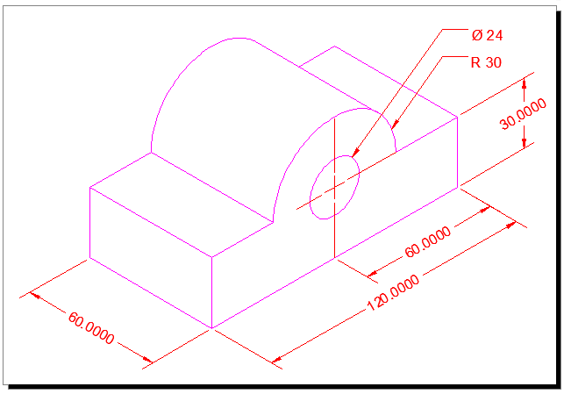
Start with the front view using the measurements you have. This drawing should be pretty simple. If you need to remember how to trim a circle, I will show you.
Your Image should look like this:
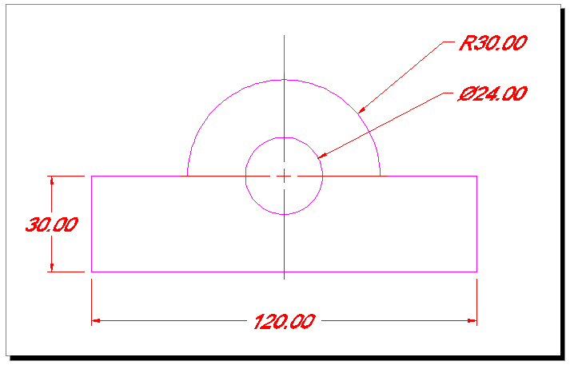
Don’t worry about dimensions yet. Now we are going to work on the top view. You will need “projection lines”. These are exactly what they sound like. Projections of the lines you will see if you are looking at the top of the objects, except you will also project hidden lines too.
NOTE: You will want to change your LTSCALE to 10.00

Here is what you should have minus the text:
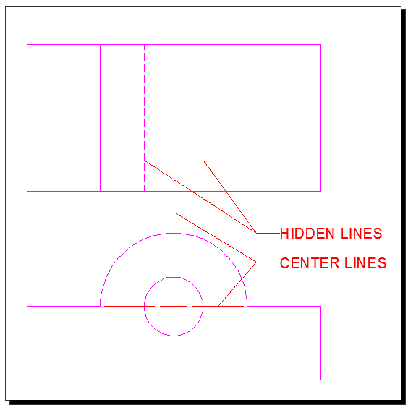
Establish projection lines for the rotation of the object view to the Right view. It should look like this in progress. Remember these projection lines are just construction lines. They will become object lines once you have trimmed it correctly.
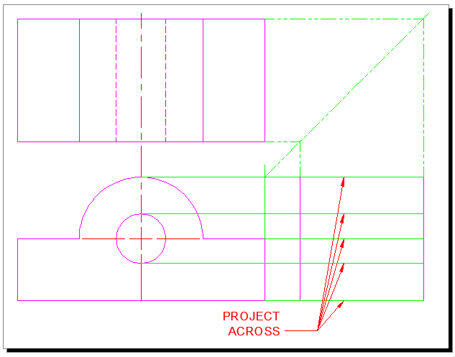
Now, trim the lines to what you should see. Remember to make hidden lines their own layer with their own line type.

Your finished project should look like this with different colors of course.

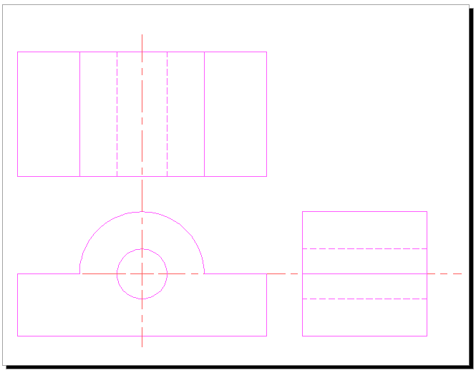
Now, dimension this drawing.

